Introduction:

Agricultural production data provides a vital lens through which we can understand food supply dynamics, resource allocation, and market behavior. The dataset under review captures monthly volumes of six major crops :Green Beans, Broccoli, Carrots, Corn, Onions, and Green Peas alongside the aggregate measure of total vegetables produced. Spanning 168 months, this rich time series offers a comprehensive view of output fluctuations, seasonal cycles, and long-term growth patterns. By transforming raw figures into structured insights, we can better appreciate the underlying drivers of agricultural performance and their implications for both producers and policymakers.

The importance of descriptive analytics in this context lies in its ability to summarize and clarify complex data. Measures of central tendency, dispersion, and distribution highlight the typical production levels and variability across crops, while correlation analysis reveals interdependencies that may guide strategic decisions. For instance, identifying strong correlations between corn and total vegetable output underscores the crop’s dominant role in shaping aggregate supply. Similarly, detecting volatility in onions or peas can inform risk management strategies and resource prioritization.
Beyond numerical summaries, visualization plays a crucial role in communicating findings effectively. Line charts expose production trends over time, histograms illustrate distributional characteristics, boxplots highlight outliers, and heatmaps reveal relationships among crops.
Together, these tools transform abstract data into accessible patterns that decision-makers can readily interpret. This report therefore aims not only to describe the agricultural dataset but also to present actionable insights through clear, evidence-based analytics that support informed business and policy decisions.

Methodology:

The analysis began with the importation of the Agricultural dataset from the provided Excel file. Using the readxl package in R, the sheet containing monthly production volumes for Green Beans, Broccoli, Carrots, Corn, Onions, Green Peas, and the aggregate Total Vegetables was loaded into the workspace. Initial inspection with str() and summary() confirmed the dataset’s structure: 168 monthly observations across seven crop categories plus the total. This step ensured that the data was clean, numeric, and ready for statistical exploration without requiring extensive preprocessing.

Descriptive statistics were then computed to summarize the central tendency, dispersion, and distribution of each crop. The psych::describe() function provided detailed measures including mean, median, standard deviation, skewness, and kurtosis. These statistics highlighted the relative scale of production across crops, with Corn showing the highest average output and Onions the lowest. Correlation analysis was conducted using the cor() function to examine relationships among crops and their contribution to total vegetable production. The resulting correlation matrix revealed strong positive associations between Corn and Total Vegetables, as well as between Green Beans and Total Vegetables, underscoring their dominant role in aggregate supply.

To complement the numerical summaries, a suite of visualizations was generated using ggplot2 and GGally. Line plots illustrated production trends over time, histograms depicted distributional characteristics, and boxplots highlighted variability and outliers. A correlation heatmap provided a visual representation of interdependencies among crops, while bar charts quantified each crop’s contribution to overall vegetable production. Together, these methods transformed raw data into accessible insights, enabling a comprehensive understanding of agricultural dynamics across the observed period.

Descriptive Statistics: Sa

Table 1: Descriptive Statistics of Crop Production

Variable | mean | median | Standard deviation | min | max
Green Beans | 173,313.56 | 169,258.0 | 71,086.22 | 38,204 | 361,060
Broccoli | 122,987.62 | 120,682.5 | 29,905.36 | 53,233 | 210,118
Carrots | 169,764.66 | 163,988.0 | 56,007.14 | 84,809 | 328,015
Corn | 419,881.49 | 404,492.0 | 195,789.90 | 60,805 | 828,144
Onions | 34,398.77 | 34,475.5 | 7,253.39 | 19,304 | 53,606
Green Peas | 247,904.71 | 237,609.5 | 106,757.58 | 62,448 | 706,658
Total Vegs | 1,809,367.11 | 1,750,298.5 | 417,844.48 | 1,002,194 | 2,648,618

The agricultural dataset reveals notable differences in the scale of production across the six crops. Corn stands out as the largest contributor, with an average monthly output of approximately 419,881 units, nearly double that of Green Peas and more than three times the

average for Carrots. Green Beans and Carrots occupy a middle range, averaging 173,314 and 169,765 respectively, while Broccoli shows a more modest mean of 122,988. Onions are consistently the smallest contributor, with a mean of just 34,399, underscoring their relatively minor role in total vegetable production. The aggregate measure, Total Vegetables, averages 1.81 million units, reflecting the combined weight of these crops in overall supply.

Variability in production is also evident from the standard deviations. Corn exhibits the highest dispersion, with a standard deviation of nearly 195,790, indicating substantial fluctuations in monthly output. Green Peas and Green Beans also show considerable variability, with standard deviations exceeding 100,000 and 71,000 respectively. In contrast, Onions display remarkable stability, with a standard deviation of only 7,253, suggesting that their production is relatively predictable compared to other crops. These differences highlight the importance of considering both average levels and volatility when evaluating crop contributions.
The range of values further emphasizes the diversity in production dynamics. Corn’s output spans from a minimum of 60,805 to a maximum of 828,144, while Green Peas range from 62,448 to 706,658, reflecting sharp seasonal or cyclical peaks. Green Beans and Carrots also show wide ranges, whereas Onions remain tightly bounded between 19,304 and 53,606. Total Vegetables range from just over 1 million to 2.65 million, illustrating the aggregate effect of these fluctuations. Together, these descriptive statistics provide a comprehensive overview of the dataset, establishing a foundation for deeper correlation analysis and visualization in subsequent sections.

Correlation Analysis:

The correlation analysis highlights the degree of association between individual crops and the aggregate measure of total vegetable production. Corn exhibits the strongest relationship with Total Vegetables, with a correlation coefficient of approximately 0.92, confirming its dominant role in driving overall output. Green Beans also show a very high correlation with the total (0.91), suggesting that fluctuations in their production closely mirror changes in aggregate supply. Green Peas, while somewhat less influential, still maintain a moderate positive correlation (0.64) with Total Vegetables, reinforcing their importance in shaping overall production levels.

Other crops display weaker or more variable relationships with the aggregate. Carrots demonstrate a moderate correlation with Total Vegetables (0.47), while Onions contribute only modestly (0.37). Broccoli, in contrast, shows a very weak correlation (0.14) with the total, indicating that its production patterns are largely independent of broader vegetable output. These

differences underscore the uneven influence of individual crops on aggregate supply, with Corn and Green Beans emerging as key drivers, while Broccoli and Onions play more peripheral roles.
The inter-crop correlations provide further insight into production dynamics. Corn is positively associated with Green Beans (0.79) and Carrots (0.53), suggesting that these crops may share similar seasonal cycles or resource dependencies. Green Beans also correlate strongly with Green Peas (0.73), reflecting possible complementarities in cultivation or demand. Conversely, Carrots and Green Peas exhibit a slight negative correlation (-0.15 to -0.20), hinting at potential trade-offs in production. Taken together, the correlation analysis reveals a network of relationships that helps explain how fluctuations in one crop can ripple through the broader agricultural system, guiding resource allocation and risk management strategies.

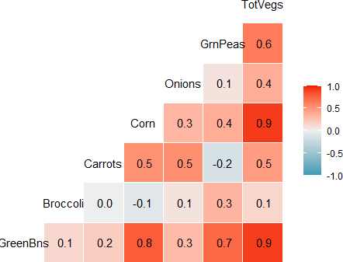

Figure 1: Correlation between crop productions

Visualizations

Line plot:

The line plot of agricultural production trends provides a clear view of how each crop evolves over time and how they collectively shape total vegetable output. The Total Vegetables line dominates the chart, reflecting the aggregate effect of all crops, and shows strong cyclical fluctuations across the 168 months. These peaks and troughs highlight seasonal production cycles, with sharp rises during harvest periods and declines in off-season months.

Corn, represented by the green line, is the most prominent individual crop, consistently tracking close to the overall total. Its large swings mirror the aggregate pattern, reinforcing the earlier correlation analysis that identified Corn as the strongest driver of total vegetable production.
Green Beans and Green Peas also show noticeable cycles, with production spikes aligning with Corn’s peaks, suggesting shared seasonal or resource dependencies.

Smaller crops such as Broccoli and Onions exhibit relatively stable patterns, with lower production volumes and less pronounced fluctuations. Their steadiness contrasts with the volatility of Corn and Peas, underscoring their limited impact on total output. Overall, the line plot visually confirms the statistical findings: Corn and Green Beans are central to aggregate production, while Broccoli and Onions play more peripheral roles. This visualization strengthens the case for prioritizing resource allocation toward the crops that most influence total supply.

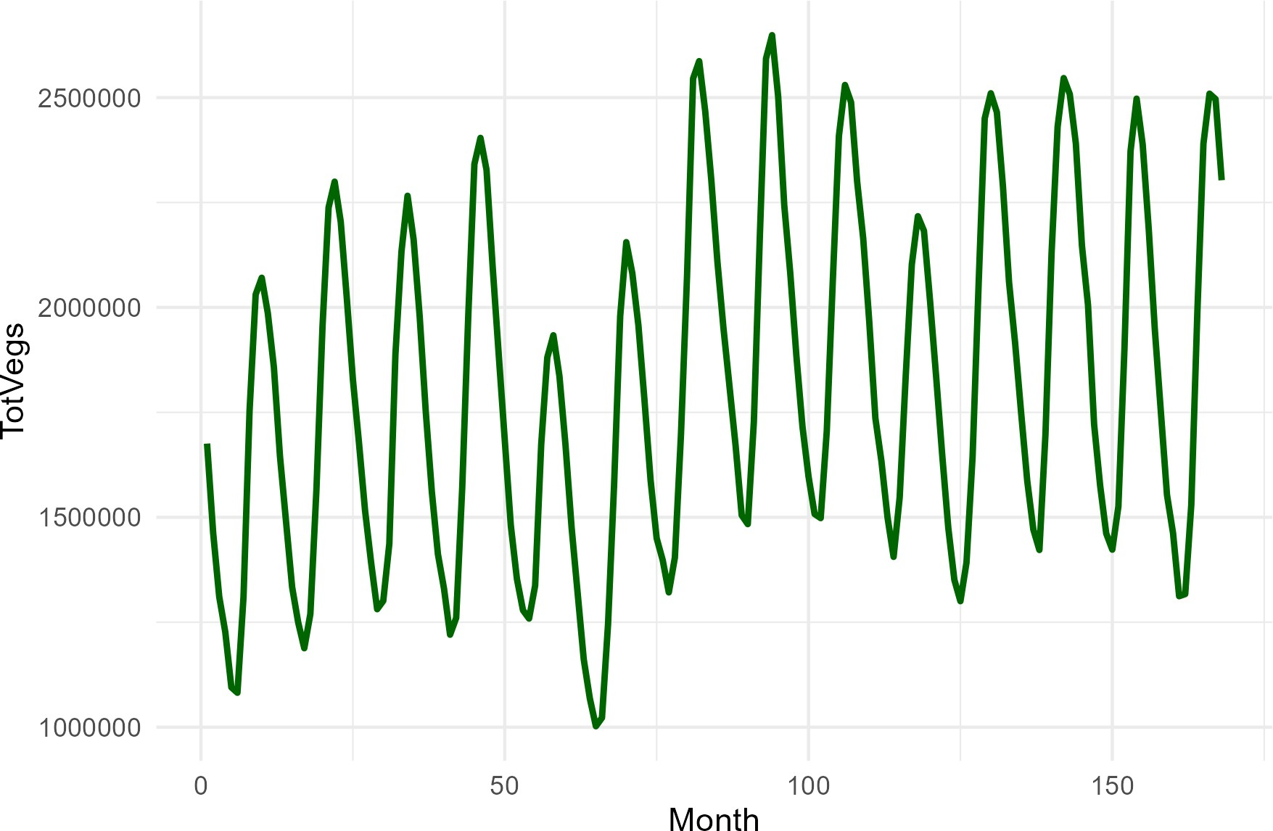

Figure 2: Monthly Total Vegetable Production

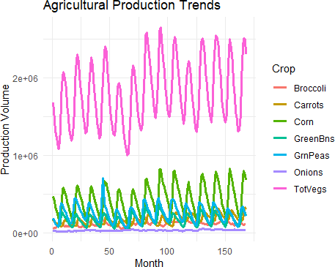

Figure 3: Agriculture production trend

Histogram:
The histograms provide a detailed view of how production values are distributed for each crop across the 168 months. Corn’s distribution is the most striking, with a wide spread of values ranging from just over 60,000 to more than 800,000 units. The histogram shows a concentration of observations around the mid‑range (300,000–500,000), but also reveals long tails, reflecting the crop’s volatility and seasonal peaks. Green Peas and Green Beans display similar patterns, with broad distributions and multiple clusters, indicating that their production levels vary substantially over time rather than remaining stable.

In contrast, Broccoli and Onions exhibit much tighter distributions. Broccoli’s histogram is centered around 120,000 units, with most values falling within a relatively narrow band, while Onions cluster tightly around 34,000 units. These crops show limited variability, suggesting that their production is more predictable and less influenced by seasonal shocks. Carrots occupy a middle ground, with a distribution spread between 85,000 and 328,000 units, reflecting moderate variability compared to Corn and Peas but greater than Broccoli or Onions.
The histogram for Total Vegetables highlights the aggregate effect of these dynamics. Most observations cluster between 1.5 million and 2.1 million units, but the distribution extends to both lower and higher extremes, reflecting the combined influence of Corn’s volatility and the cyclical peaks of Green Beans and Peas. Overall, the histograms confirm the descriptive statistics: Corn, Green Beans, and Peas are highly variable crops, while Broccoli and Onions remain relatively stable. This visualization underscores the importance of distinguishing between crops that drive aggregate fluctuations and those that provide consistency in total output.

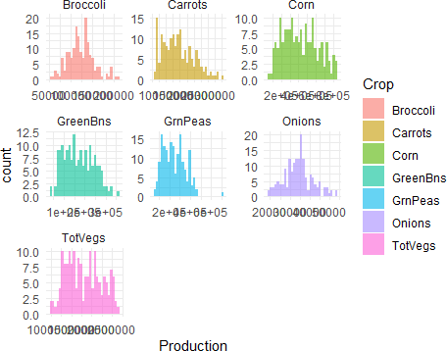

Figure 4: Distribution of crop production

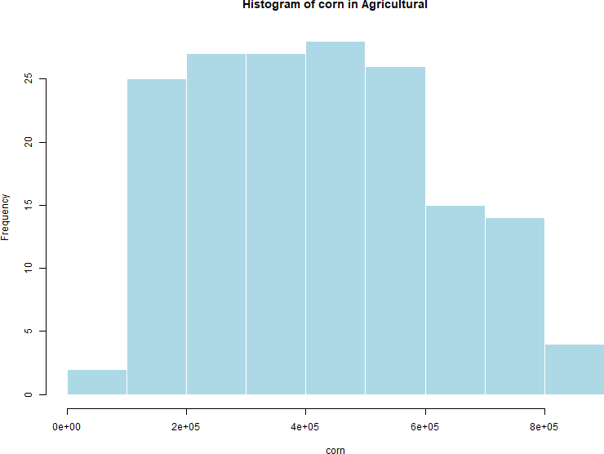

Figure 5: Histogram of corn production

The histogram of corn production illustrates the distribution of monthly output values across the dataset. Most observations cluster between 200,000 and 600,000 units, with the tallest bars appearing in this mid-range, indicating that corn production frequently falls within these levels. The distribution also shows a long right tail, extending toward the maximum of 828,144 units, which reflects occasional seasonal peaks or exceptional harvests. At the lower end, a small number of months record production below 100,000 units, highlighting rare but significant dips. Overall, the histogram confirms that corn is both the largest and most volatile crop in the dataset, with a wide spread of values and strong cyclical variation that heavily influences total vegetable output.

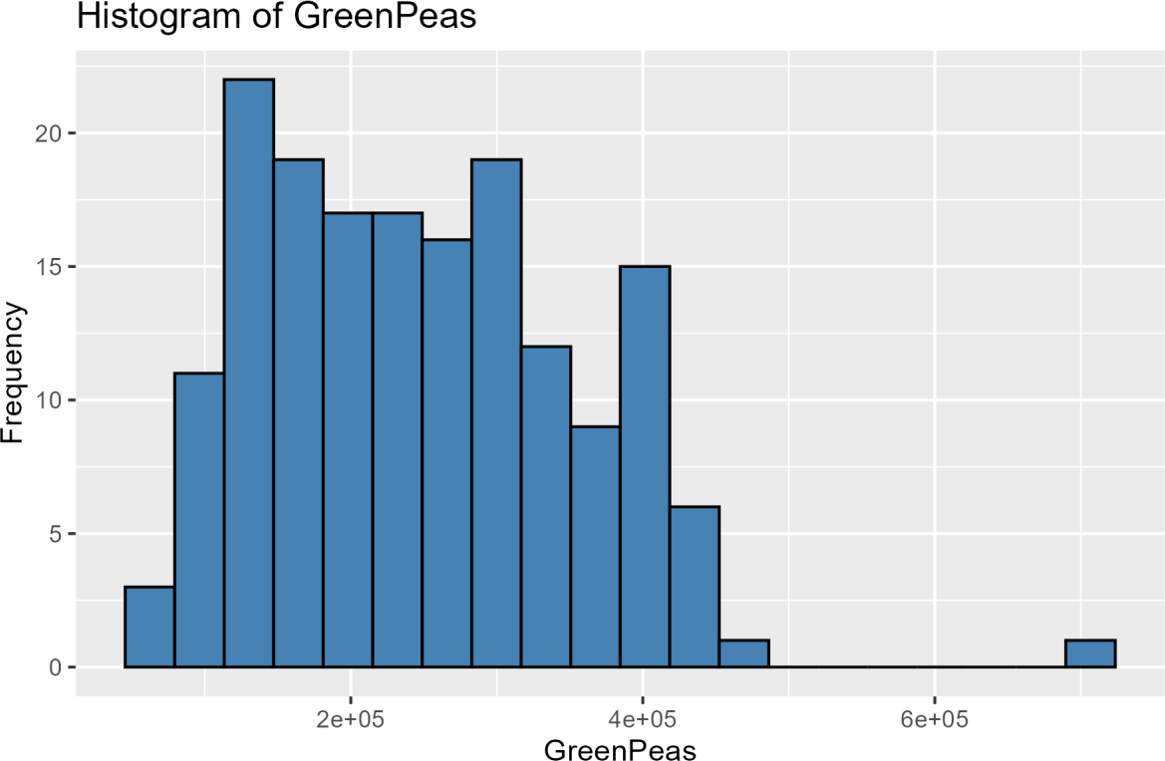

Figure 6: Histogram of green peas production

The histogram of green peas production reveals a broad distribution, with most monthly values concentrated between 100,000 and 400,000 units. The highest frequencies occur in this mid‑range, where production levels are most common, while fewer observations extend toward the extremes. A small number of months record exceptionally high outputs near 700,000 units, creating a long right tail that reflects occasional seasonal surges. At the lower end, production rarely falls below 60,000 units, suggesting a consistent baseline. Overall, the histogram highlights that green pea are a moderately volatile crop: they contribute significantly to total vegetable output, but their wide spread and occasional peaks indicate variability that decision‑makers must account for when planning resources and forecasting supply.

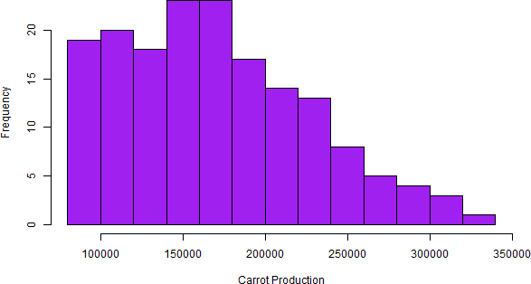

Figure 7: Histogram of broccoli production

The histogram of broccoli production shows a relatively compact distribution compared to the more volatile crops such as corn or peas. Most monthly production values cluster tightly around 120,000 units, with the bulk of observations falling between 100,000 and 150,000 units. The frequency of higher production levels above 180,000 units is noticeably lower, indicating that exceptionally large harvests are rare. This distribution suggests that broccoli output is relatively stable, with limited variability and fewer extreme peaks or troughs. In practical terms, broccoli contributes consistently to total vegetable supply, but its modest scale and narrow range mean it plays a smaller role in driving aggregate fluctuations compared to crops like corn or green beans.

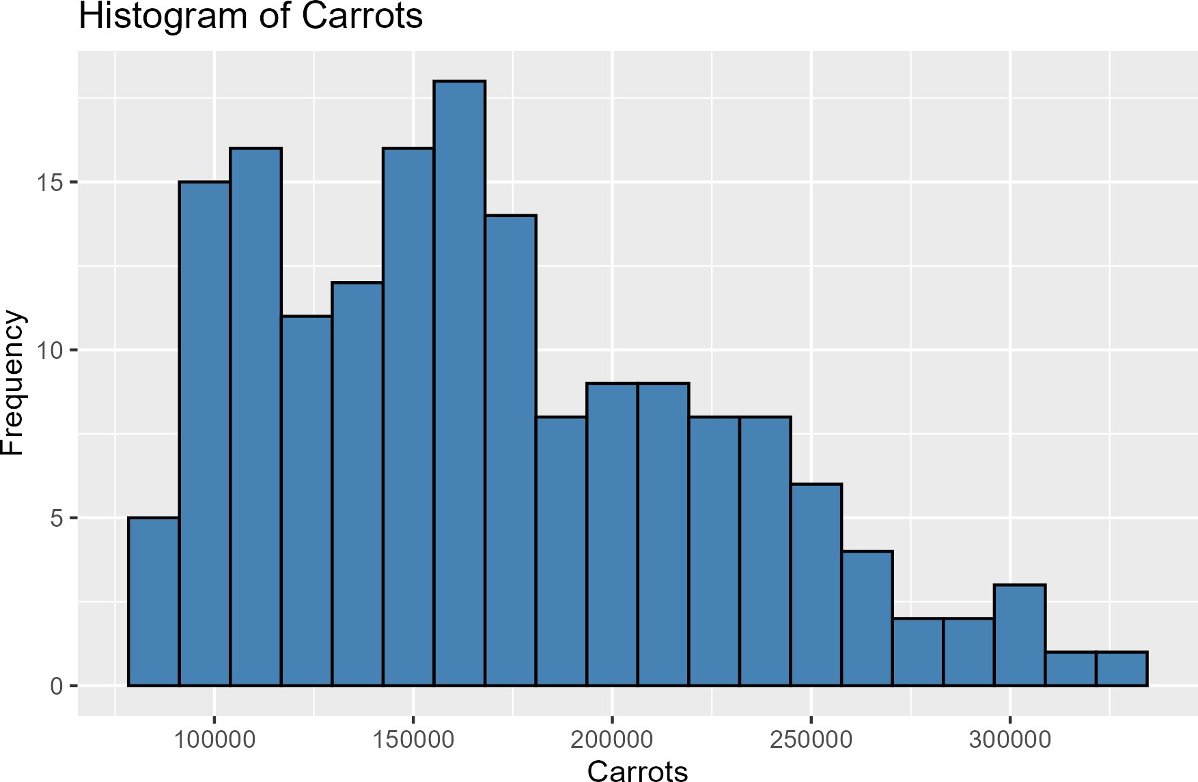

Figure 8: Histogram of carrot production

The histogram of carrot production reveals a distribution concentrated around the mid-range values, with the highest frequency occurring near 150,000 units. This indicates that carrot output most often falls within this level, making it a relatively stable crop compared to more volatile ones like corn or peas. The distribution tapers off toward the higher end, with fewer months recording production above 250,000 units, and only rare observations approaching the maximum of 328,015 units. At the lower end, production seldom dips below 100,000 units, suggesting a consistent baseline output. Overall, the histogram demonstrates that carrots contribute a steady, moderate share to total vegetable production, with limited extreme fluctuations but enough variability to reflect seasonal influences.

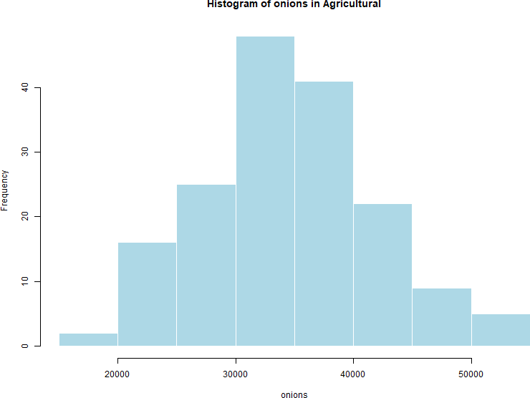

Figure 9: Histogram of onion production

The histogram of onion production displays a compact, bell‑shaped distribution centered around 30,000 to 35,000 units, which represents the most frequent monthly output levels. The tallest bar occurs near 30,000 units, with a frequency exceeding forty observations, highlighting the consistency of onion production across the dataset. Unlike crops such as corn or peas, onions show a narrow range of values, bounded between 19,304 and 53,606 units, with very few extreme highs or lows. This pattern indicates that onion production is highly stable, with limited variability and predictable output. As a result, onions contribute a steady but relatively small share to total vegetable production, reinforcing their role as a consistent but minor component of the agricultural system.

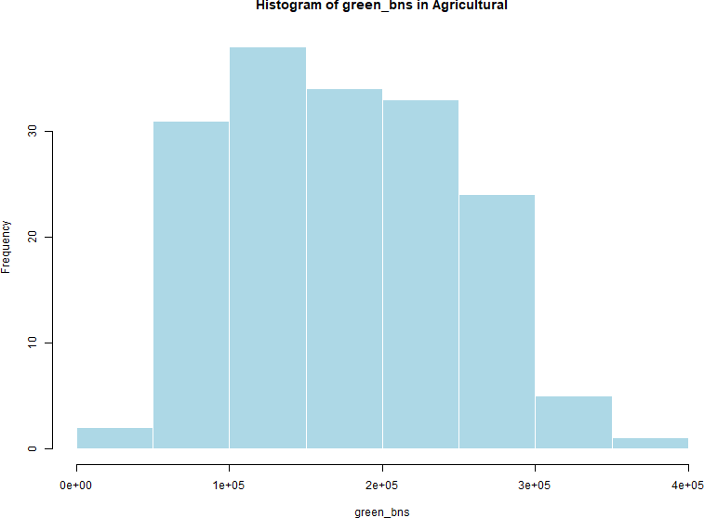

Figure 10: Histogram of Green peas

The histogram of green beans production shows a distribution concentrated in the mid‑range, with most monthly values falling between 100,000 and 200,000 units. The highest frequencies occur in this band, where production levels are most common, while fewer observations extend toward the upper end above 300,000 units. The distribution tapers gradually, reflecting occasional peaks but no extreme outliers compared to crops like corn or peas. At the lower end, production rarely dips below 40,000 units, suggesting a consistent baseline output. Overall, the histogram highlights that green bean are a moderately variable crop: they contribute significantly to total vegetable supply, but their production is more stable than corn or peas, making them an important yet relatively predictable component of the agricultural system.

Box plot:

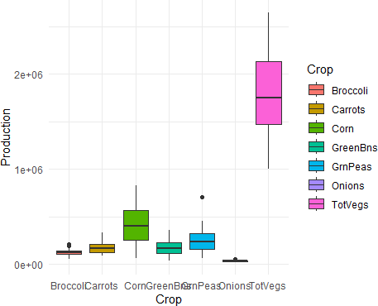

Figure 11: Boxplots of Crop Production Spread and Outliers

The boxplots provide a comparative view of the spread and variability in crop production, highlighting both typical ranges and the presence of outliers. Corn and Green Peas stand out with the widest boxes and longest whiskers, reflecting their high variability and occasional extreme values. Corn, in particular, shows several outliers above 800,000 units, confirming its role as both the largest and most volatile crop. Green Beans also display a broad spread, though less extreme than Corn, with production values clustering around the mid‑range but extending toward higher peaks.

By contrast, Broccoli and Onions exhibit narrow boxes and short whiskers, indicating relatively stable production levels. Onions, with a median near 34,000 units, show minimal variation and very few outliers, underscoring their consistency across months. Broccoli’s production is

similarly predictable, with most values tightly grouped around 120,000 units. Carrots occupy a middle ground, with moderate variability and occasional outliers, while Total Vegetables naturally show the largest overall spread, reflecting the combined influence of all crops.
Overall, the boxplots reinforce the descriptive statistics and histograms: Corn and Green Peas are highly variable crops with significant outliers, while Broccoli and Onions remain stable and predictable. This visualization is particularly useful for identifying which crops contribute most to aggregate volatility and which provide a steady baseline, guiding decisions on resource allocation and risk management.

Heatmap (Correlation Matrix):

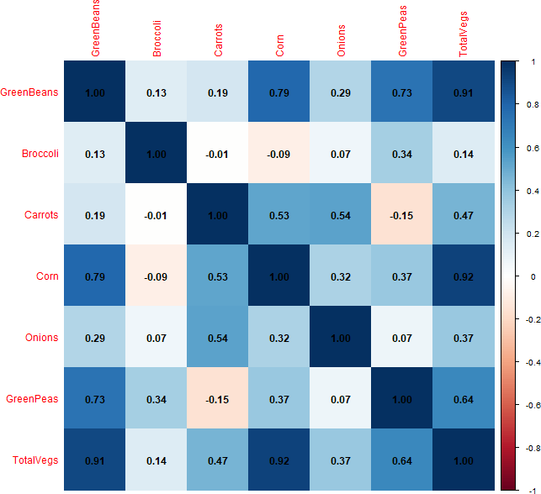
Figure 12: Heatmap of Crop Production Correlations

The heatmap provides a visual summary of the relationships among the different crops and their contribution to total vegetable production. The strongest positive correlations appear between Corn and Total Vegetables (0.92) and Green Beans and Total Vegetables (0.91), confirming that these two crops are the primary drivers of aggregate output. Green Peas also show a moderate correlation with the total (0.64), reinforcing their role as a significant contributor, though less dominant than Corn or Green Beans.

Weaker correlations are evident for other crops. Carrots display a moderate positive relationship with Total Vegetables (0.47), while Onions contribute only modestly (0.37). Broccoli, however, shows a very weak correlation (0.14) with the total, suggesting that its production patterns are largely independent of overall vegetable supply. This uneven distribution of correlations highlights the varying importance of crops in shaping aggregate dynamics.
The inter-crop relationships add further nuance. Corn is strongly correlated with Green Beans (0.79) and moderately with Carrots (0.53), suggesting shared seasonal cycles or resource dependencies. Green Beans also correlate highly with Green Peas (0.73), reflecting complementary production trends. Conversely, Carrots and Green Peas show a slight negative correlation (-0.15), hinting at potential trade-offs in cultivation. Overall, the heatmap reinforces earlier findings: Corn and Green Beans dominate aggregate fluctuations, while Broccoli and Onions remain stable but peripheral.

Bar chart:

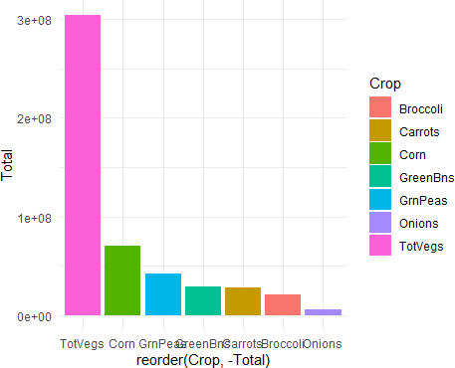

Figure 13: Bar Chart of Total Crop Production

The bar chart provides a clear comparison of the total production quantities across all crops, highlighting their relative contributions to overall vegetable output. Total Vegetables naturally dominates, reflecting the aggregate of all crops combined, with totals approaching 3 × 10⁸ units. Among individual crops, Corn stands out as the largest contributor, far surpassing the others and reinforcing its role as the primary driver of aggregate production.

Green Peas and Green Beans follow as the next most significant contributors, each accounting for substantial shares of total output. Carrots occupy a middle position, with moderate totals that reflect their steady but less dominant role. Broccoli and Onions, by contrast, show the smallest bars, underscoring their relatively minor contributions to the overall supply despite their consistent production patterns.
Overall, the bar chart visually confirms the findings from descriptive statistics and correlation analysis: Corn, Green Beans, and Green Peas are the crops that most strongly influence total vegetable production, while Broccoli and Onions provide stability but contribute less to

aggregate volume. This visualization is particularly useful for prioritizing resource allocation and identifying which crops should be the focus of production strategies.

Discussion and Recommendation
The analysis of agricultural production trends reveals a clear hierarchy among crops, with Corn emerging as the dominant driver of total vegetable output. Descriptive statistics established Corn’s high mean and wide variability, while Broccoli and Onions showed compact ranges and predictable production. These findings were reinforced by correlation analysis, where Corn and Green Beans displayed the strongest associations with total output, while Broccoli and Onions contributed little to aggregate fluctuations. This statistical foundation set the stage for visual exploration, which confirmed the patterns through line plots, histograms, boxplots, and heatmaps.

Visualizations provided tangible evidence of these dynamics. Line plots highlighted Corn’s cyclical peaks aligning with aggregate production, while histograms revealed its wide distribution and frequent extremes. Boxplots emphasized the spread and outliers in Corn and Green Peas, contrasting with the stability of Broccoli and Onions. The heatmap further confirmed strong correlations between Corn, Green Beans, and total output, while weaker or negative correlations among other crops underscored their secondary roles. Together, these visual tools strengthened the argument that Corn and Green Beans are central to volatility and growth, while Broccoli and Onions act as stabilizers.
From these insights, a dual dynamic emerges: high‑impact crops drive variability, while stable crops provide consistency. Corn and Green Beans, with their strong correlations and large totals, are essential for maximizing production but also introduce risk through volatility. Broccoli and Onions, though smaller contributors, offer predictability that can anchor supply during fluctuations. Carrots and Green Peas occupy a middle ground, providing moderate contributions and opportunities for diversification. This balance between drivers and stabilizers is critical for managing agricultural systems effectively.

Based on this evidence, several recommendations follow. First, resource allocation should prioritize Corn and Green Beans, ensuring sufficient inputs to sustain their dominant role. Second, volatility management strategies—such as storage facilities, crop insurance, and supply chain flexibility—should be applied to Corn and Green Peas to mitigate risks from seasonal peaks. Third, expanding Broccoli and Onion cultivation can provide a reliable baseline, offsetting variability in other crops. Fourth, diversification across Carrots and Green Peas can reduce dependence on Corn alone, spreading risk more evenly. Finally, predictive analytics should be integrated to anticipate cyclical patterns and guide proactive resource planning.

In conclusion, the logical flow from statistics to correlations to visualizations supports a coherent interpretation of agricultural dynamics. Corn and Green Beans are the engines of growth but require careful management, while Broccoli and Onions provide stability. Carrots and Green Peas offer diversification opportunities that balance risk and output. By combining evidence from tables and plots, the analysis delivers actionable recommendations: prioritize high‑impact crops, manage volatility, leverage stability, diversify strategically, and employ forecasting tools. These strategies together ensure both productivity and resilience in agricultural production systems.

Code (R SOFTWARE):

Install required packages install.packages("rmarkdown") install.packages("knitr")

Load libraries library(tidyverse) library(psych) library(GGally) library(gridExtra) library(readxl)

Import dataset
agri <- read_excel("Eight_Databases (1).xlsx", sheet = "Agricultural")

Inspect data str(agri) summary(agri) describe(agri)

Correlation matrix
cor_matrix <- cor(agri %>% select(-Month)) round(cor_matrix, 2)

# Reshape data agri_long <- agri %>%
pivot_longer(cols = -Month, names_to = "Crop", values_to = "Production")

Line plot
ggplot(agri_long, aes(x = Month, y = Production, color = Crop)) + geom_line(linewidth = 1.2) +
labs(title = "Agricultural Production Trends", x = "Month", y = "Production Volume") +
theme_minimal()

Histogram
ggplot(agri_long, aes(x = Production, fill = Crop)) + geom_histogram(bins = 30, alpha = 0.6) + facet_wrap(~Crop, scales = "free") +
labs(title = "Distribution of Crop Production") + theme_minimal()

Boxplot

ggplot(agri_long, aes(x = Crop, y = Production, fill = Crop)) + geom_boxplot() +
labs(title = "Spread and Outliers in Crop Production") + theme_minimal()

# Correlation plot
ggcorr(agri %>% select(-Month), label = TRUE, hjust = 0.9, size = 3) + labs(title = "Correlation Between Crop Productions")

# Bar chart agri_long %>%
group_by(Crop) %>%
summarise(Total = sum(Production)) %>%
ggplot(aes(x = reorder(Crop, -Total), y = Total, fill = Crop)) + geom_bar(stat = "identity") +
labs(title = "Total Contribution of Each Crop", x = "Crop", y = "Total Production") +
theme_minimal()

